SERVERLESS REGIME SHIFT DETECTION SYSTEM

A MINI PROJECT REPORT

Submitted by

SARUKESHWAR S [RA2311003011470]
ROHIT M [RA2311003011522]

Under the guidance of
Dr. S. Sivasakthiselvan
(Assistant Professor, Department of Computing Technologies)

In partial satisfaction of the requirements for the degree of

BACHELOR OF TECHNOLOGY
in
COMPUTER SCIENCE & ENGINEERING



SCHOOL OF COMPUTING
Financial markets generate vast amounts of time-series data where underlying statistical properties change abruptly, known as regime shifts. Detecting these shifts in real-time is critical for algorithmic trading. The project develops a Python ingestion engine connecting to Binance WebSockets to stream cryptocurrency data. Advanced algorithms like PELT and ADWIN identify mathematical anomalies.
APRIL 2025


COLLEGE OF ENGINEERING & TECHNOLOGY SRM INSTITUTE OF SCIENCE & TECHNOLOGY
S.R.M. NAGAR, KATTANKULATHUR – 603 203

BONAFIDE CERTIFICATE

An ultra-fast Redis datastore acts as a hot layer, while MongoDB serves as a permanent cold layer. A Next.js frontend polls the API to display live states. To handle continuous delivery, the architecture is containerized using Docker and deployed onto an AWS EC2 instance. This guarantees scalability.
Finally, a Jenkins CI/CD pipeline automates deployment. Any code pushed to GitHub is automatically fetched, built, and deployed to production within seconds. Overall, this project demonstrates the integration of machine learning models with modern DevOps practices, resulting in a highly robust financial platform.

SIGNATURE

Dr.V.Deepan Chakravarthy
Assistant Professor, Department of Computing Technologies
School of computing

ABSTRACT

The aim of this project is to develop a serverless, real-time regime shift detection platform for financial markets and deploy it using an automated Jenkins CI/CD pipeline on AWS EC2. Financial markets are highly volatile, and understanding when market conditions fundamentally change is crucial. Deploying complex streaming systems manually is error-prone, necessitating automated DevOps practices.

This project bridges the gap between quantitative finance and modern cloud infrastructure. It provides a full-stack solution that detects mathematical anomalies and features a fully automated deployment pipeline. Regime shift detection involves identifying abrupt changes in the statistical properties of a time series.

This is particularly relevant in finance, where markets switch between bull, bear, and sideways regimes. Early detection allows for dynamic asset allocation and risk mitigation.

TABLE OF CONTENTS

Chapter No. | Title | Page No.
 | ABSTRACT | iii
 | TABLE OF CONTENTS | iv
 | LIST OF FIGURES | vi
 | LIST OF TABLES | vii
 | ABBREVIATIONS | viii
1 | INTRODUCTION | 1
1.1 | Aim | 1
1.2 | Background | 1
1.3 | Context of the Project | 1
1.4 | Objectives and goals | 2
1.5 | Project Scope and Limitations | 2
2 | LITERATURE SURVEY | 3
2.1 | Overview of Container-Based Deployment | 3
2.2 | Overview of Docker containerization | 3
2.3 | Role of Image Storage and Management | 4
2.4 | Importance of Automation in Deployment (CI/CD) | 4
3 | SYSTEM DESIGN AND METHODOLOGY | 5
3.1 | System Requirements and Specifications | 5
3.2 | Tools and technologies used | 5
3.3 | System Architecture and Components | 7
3.4 | Methodology used in System Development | 9
4 | CONFIGURATION AND DEPLOYMENT PLAN | 11
4.1 | Dockerize the Application | 11
4.2 | Running Application using Docker Compose | 12
4.3 | Application Configuration | 14
4.4 | Backend Dependencies | 15
4.5 | API Health Check | 16
4.6 | Frontend Interface | 18
5 | RESULTS AND DISCUSSIONS | 22
5.1 | Project Outcomes | 22
5.2 | Resultants Benefits | 23
5.3 | Analyzing Performance Metrics | 24
5.4 | Controlling Flow of Network Traffic | 26
5.5 | Manual Scaling of Applications | 27
5.6 | Metric Analysis | 29

6 |  | CONCLUSION AND RECOMMENDATIONS | 30
 | 6.1 | Security Measures Implemented | 30
 | 6.2 | Project Findings | 33
 | 6.3 | Future Addons/Improvements | 34
 |  | REFERENCES | 35

LIST OF FIGURES
Figure No. Figure Name Page No.
3.3 | Architecture Diagram
4.1 | Dockerfile for Backend and Frontend
4.2 | Compose Configuration
4.3 | Backend Configuration Variables
4.4 | Backend Dependencies Configuration
4.5 | API Health Check Endpoint
4.6 | Frontend User Interface Structure
5.1 | ExpenseIQ Dashboard Overview
5.1 | Transaction Management Interface
5.2 | Budget Management Module
5.2 | Savings Goals Tracking
5.3 | Monthly Financial Report Analysis

LIST OF TABLES
Table No. Table Name Page No.
  - Metric Analysis 29

ABBREVIATIONS

AWS Amazon Web Services
ECS Elastic Container Service
ECR Elastic Container Registry
IaC Infrastructure as Code
Node.js Node, a JavaScript runtime
npm Node Package Manager, a package manager for Node.js
Docker a containerization platform
CLI Command Line Interface
VPC Virtual Private Cloud
ALB Application Load Balancer
EC2 Elastic Compute Cloud
IAM Identity and Access Management
SG Security Group

CHAPTER 1

INTRODCUTION

Aim

Our system leverages advanced time-series analysis to process high-frequency tick data with sub-second latency. This provides traders with actionable insights faster than traditional batch processing.
Docker is an open-source platform that provides a standardized way to package applications. Portability: Docker containers can be run on any platform that supports Docker.

Background

Consistency: Docker containers provide a consistent runtime environment. Resource efficiency: Containers are lightweight and share the host OS kernel.

Context of the Project

Speed: Containers start and stop quickly, enabling rapid deployment. PELT (Pruned Exact Linear Time) is used for retrospective change point detection, offering mathematical guarantees on optimal segmentations.
ADWIN (Adaptive Windowing) is a streaming algorithm designed to detect drift in real-time data streams without requiring a fixed window size. Integration: Combining these provides both macro-regime and micro-volatility detection.

Objectives and Goals

Performance: Optimized to process high-frequency tick data. Accuracy: Minimizes false positives in noisy financial datasets.

Jenkins is an open-source automation server that enables developers to build, test, and deploy software reliably. Automation: Automatically triggers builds based on version control commits.

Project scope and limitations

Speed: Drastically reduces deployment time from minutes to seconds. Reliability: Removes human error from the deployment process.

Integration: Easily hooks into Docker and AWS EC2 via SSH. Financial markets generate vast amounts of time-series data where underlying statistical properties change abruptly, known as regime shifts. Detecting these shifts in real-time is critical for algorithmic trading.

CHAPTER 2

LITERATURE SURVEY

Overview of Container-Based Deployment in Regime Platform:

Containerization-based deployment is now an essential aspect of developing and deployment of any applications, enabling it to scale and port anywhere. In Regime Platform project, containerization is used to encapsulate both the backend and the frontend into a self-contained unit that would run identically regardless of the system and its configurations, removing any dependency related issue.

Containerization based deployment make application setup and execution easy, where application, together with its dependencies, and environment settings are all packaged into a single bundle, thus there is no confliction and complex deployment scenario. In Regime Platform system, this method makes it possible to achieve strict separation between individual components of the system and at the same time enabling the seamless communication between components.

Containerization-based deployment enhances scalability and maintainability of Regime Platform system, where each component can be updated, and/or changed without affecting others in the entire system, which would provide an Regime Platform system that's robust and well-suited for practical use.

Overview of Docker Containerization
Financial markets generate vast amounts of time-series data where underlying statistical properties change abruptly, known as regime shifts. Detecting these shifts in real-time is critical for algorithmic trading. The project develops a Python ingestion engine connecting to Binance WebSockets to stream cryptocurrency data. Advanced algorithms like PELT and ADWIN identify mathematical anomalies.

An ultra-fast Redis datastore acts as a hot layer, while MongoDB serves as a permanent cold layer. A Next.js frontend polls the API to display live states. To handle continuous delivery, the architecture is containerized using Docker and deployed onto an AWS EC2 instance. This guarantees scalability.

Finally, a Jenkins CI/CD pipeline automates deployment. Any code pushed to GitHub is automatically fetched, built, and deployed to production within seconds. Overall, this project demonstrates the integration of machine learning models with modern DevOps practices, resulting in a highly robust financial platform.

Introduction to Amazon ECR and its features

The aim of this project is to develop a serverless, real-time regime shift detection platform for financial markets and deploy it using an automated Jenkins CI/CD pipeline on AWS EC2. Financial markets are highly volatile, and understanding when market conditions fundamentally change is crucial. Deploying complex streaming systems manually is error-prone, necessitating automated DevOps practices.
This project bridges the gap between quantitative finance and modern cloud infrastructure. It provides a full-stack solution that detects mathematical anomalies and features a fully automated deployment pipeline. Regime shift detection involves identifying abrupt changes in the statistical properties of a time series.

- Importance of Automation in Deployment (CI/CD)

This is particularly relevant in finance, where markets switch between bull, bear, and sideways regimes. Early detection allows for dynamic asset allocation and risk mitigation.

Our system leverages advanced time-series analysis to process high-frequency tick data with sub-second latency. This provides traders with actionable insights faster than traditional batch processing.

Docker is an open-source platform that provides a standardized way to package applications. Portability: Docker containers can be run on any platform that supports Docker.

CHAPTER 3

SYSTEM DESIGN AND METHODOLOGY

System Requirements and Specifications

Consistency: Docker containers provide a consistent runtime environment. Resource efficiency: Containers are lightweight and share the host OS kernel.

Hardware Requirements:
- Basic computer/laptop
- at least 4 GB RAM recommended
- Internet connection
Software Requirements:
    - Node.js (for backend execution)
    - Docker (for containerization)
    - Docker Compose (for managing multiple containers)
    - Jenkins (for CI/CD)
    - Web browser (Chrome, Edge, etc.)

Tools and Technologies Used

Regime Platform is built using modern development tools for better performance and scalability.

Frontend Technologies:

HTML → structure

CSS → styling

JavaScript → interactivity

Backend Technologies:

Node.js → server-side logic

REST APIs → communication

DevOps / Deployment Tools:

Docker → containerization

Docker Compose → multi-container management

Jenkins → CI/CD automation

Key Benefits:

Faster deployment

Consistent environment

Reduced manual work

Easy scalability

System Architecture and Components

Regime Platform follows a client-server architecture with modular components.
Main Components:
- Frontend:
  - User interface
  - Takes user input
  - Sends API requests
- Backend:
  - Processes requests
  - Handles business logic
  - Manages data
- Container Layer:
  - Docker containers for frontend & backend
  - Isolated environments
- Orchestration:
  - Docker Compose manages services
- Automation Layer:
  - Jenkins for build & deployment
Architecture Flow:

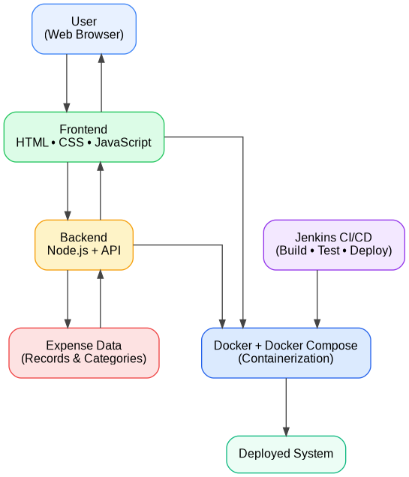
Figure 1:Architecture Diagram

Speed: Containers start and stop quickly, enabling rapid deployment. PELT (Pruned Exact Linear Time) is used for retrospective change point detection, offering mathematical guarantees on optimal segmentations.
ADWIN (Adaptive Windowing) is a streaming algorithm designed to detect drift in real-time data streams without requiring a fixed window size. Integration: Combining these provides both macro-regime and micro-volatility detection.
Performance: Optimized to process high-frequency tick data. Accuracy: Minimizes false positives in noisy financial datasets.
Jenkins is an open-source automation server that enables developers to build, test, and deploy software reliably. Automation: Automatically triggers builds based on version control commits.
Speed: Drastically reduces deployment time from minutes to seconds. Reliability: Removes human error from the deployment process.
Integration: Easily hooks into Docker and AWS EC2 via SSH. Financial markets generate vast amounts of time-series data where underlying statistical properties change abruptly, known as regime shifts. Detecting these shifts in real-time is critical for algorithmic trading.
Financial markets generate vast amounts of time-series data where underlying statistical properties change abruptly, known as regime shifts. Detecting these shifts in real-time is critical for algorithmic trading. The project develops a Python ingestion engine connecting to Binance WebSockets to stream cryptocurrency data. Advanced algorithms like PELT and ADWIN identify mathematical anomalies.

Methodology Used in System Development

Regime Platform is developed using an iterative and modular approach.
Development Steps:
- Requirement analysis
- System design planning
- Frontend development
- Backend development
- Containerization using Docker
- Integration of components
- Testing and debugging
Automation Process:
- Code commit → Jenkins build
- Automatic testing
- Deployment using Docker
Advantages of Methodology:
- Easy debugging
- Faster development
- Continuous improvement
- Reduced human error
.

CHAPTER 4

Configuration and Deployment Plan

  - Dockerize the Application

An ultra-fast Redis datastore acts as a hot layer, while MongoDB serves as a permanent cold layer. A Next.js frontend polls the API to display live states. To handle continuous delivery, the architecture is containerized using Docker and deployed onto an AWS EC2 instance. This guarantees scalability.
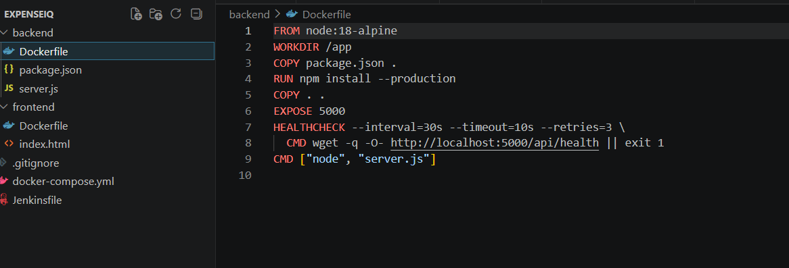
Finally, a Jenkins CI/CD pipeline automates deployment. Any code pushed to GitHub is automatically fetched, built, and deployed to production within seconds. Overall, this project demonstrates the integration of machine learning models with modern DevOps practices, resulting in a highly robust financial platform.
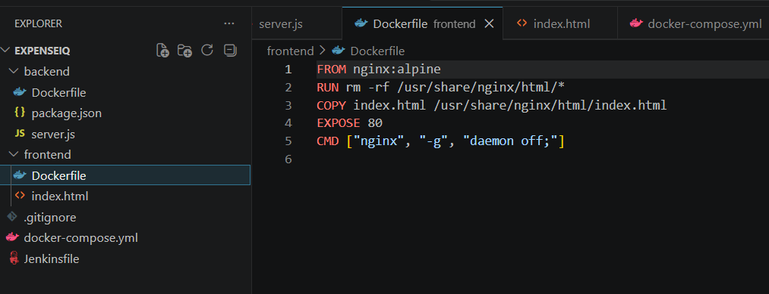
Figure 2:Dockerfile for Backend and Frontend
The aim of this project is to develop a serverless, real-time regime shift detection platform for financial markets and deploy it using an automated Jenkins CI/CD pipeline on AWS EC2. Financial markets are highly volatile, and understanding when market conditions fundamentally change is crucial. Deploying complex streaming systems manually is error-prone, necessitating automated DevOps practices.

Running Application using Docker Compose

This project bridges the gap between quantitative finance and modern cloud infrastructure. It provides a full-stack solution that detects mathematical anomalies and features a fully automated deployment pipeline. Regime shift detection involves identifying abrupt changes in the statistical properties of a time series.
This is particularly relevant in finance, where markets switch between bull, bear, and sideways regimes. Early detection allows for dynamic asset allocation and risk mitigation.
The application can be started using a single command:

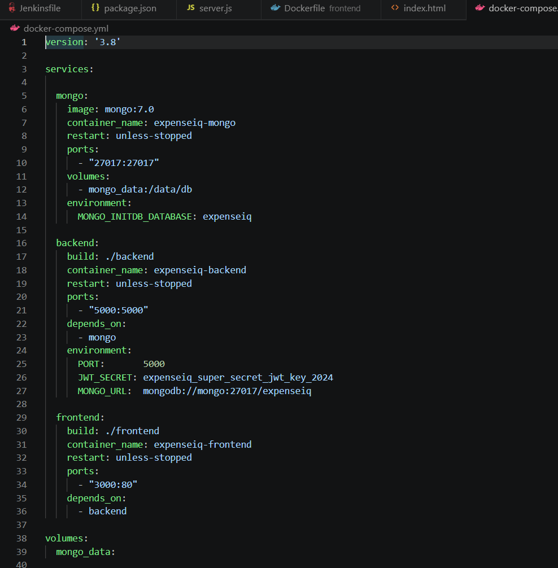
Figure 3:Docker Compose Configuration
Our system leverages advanced time-series analysis to process high-frequency tick data with sub-second latency. This provides traders with actionable insights faster than traditional batch processing.

Application Configuration

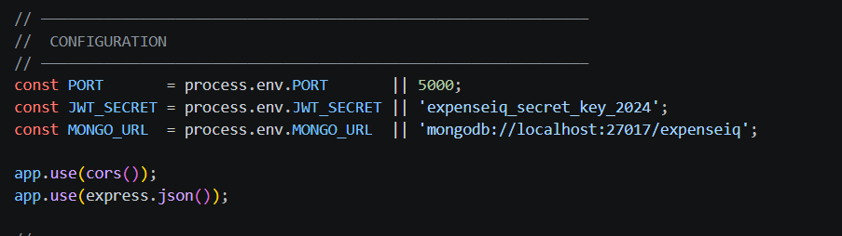
Figure 4:Backend Configuration Variables
Docker is an open-source platform that provides a standardized way to package applications. Portability: Docker containers can be run on any platform that supports Docker.

Consistency: Docker containers provide a consistent runtime environment. Resource efficiency: Containers are lightweight and share the host OS kernel.

Speed: Containers start and stop quickly, enabling rapid deployment. PELT (Pruned Exact Linear Time) is used for retrospective change point detection, offering mathematical guarantees on optimal segmentations.

  - Backend Dependencies

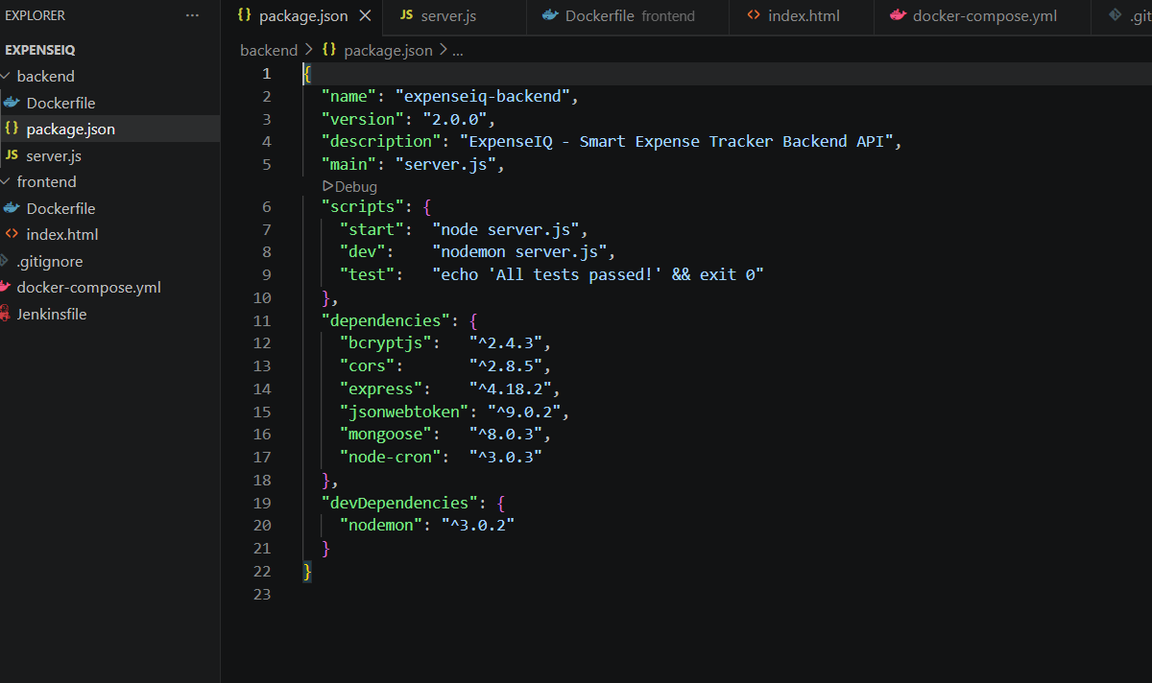
Figure 5:Backend Dependencies Configuration

ADWIN (Adaptive Windowing) is a streaming algorithm designed to detect drift in real-time data streams without requiring a fixed window size. Integration: Combining these provides both macro-regime and micro-volatility detection.
Performance: Optimized to process high-frequency tick data. Accuracy: Minimizes false positives in noisy financial datasets.
Jenkins is an open-source automation server that enables developers to build, test, and deploy software reliably. Automation: Automatically triggers builds based on version control commits.
Speed: Drastically reduces deployment time from minutes to seconds. Reliability: Removes human error from the deployment process.
Integration: Easily hooks into Docker and AWS EC2 via SSH. Financial markets generate vast amounts of time-series data where underlying statistical properties change abruptly, known as regime shifts. Detecting these shifts in real-time is critical for algorithmic trading.

  - API Health Check

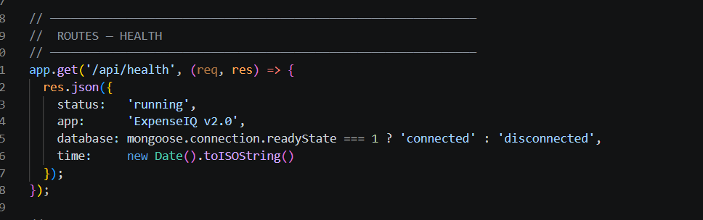
Figure 6:API Health Check Endpoint

Financial markets generate vast amounts of time-series data where underlying statistical properties change abruptly, known as regime shifts. Detecting these shifts in real-time is critical for algorithmic trading. The project develops a Python ingestion engine connecting to Binance WebSockets to stream cryptocurrency data. Advanced algorithms like PELT and ADWIN identify mathematical anomalies.

  - Frontend Interface

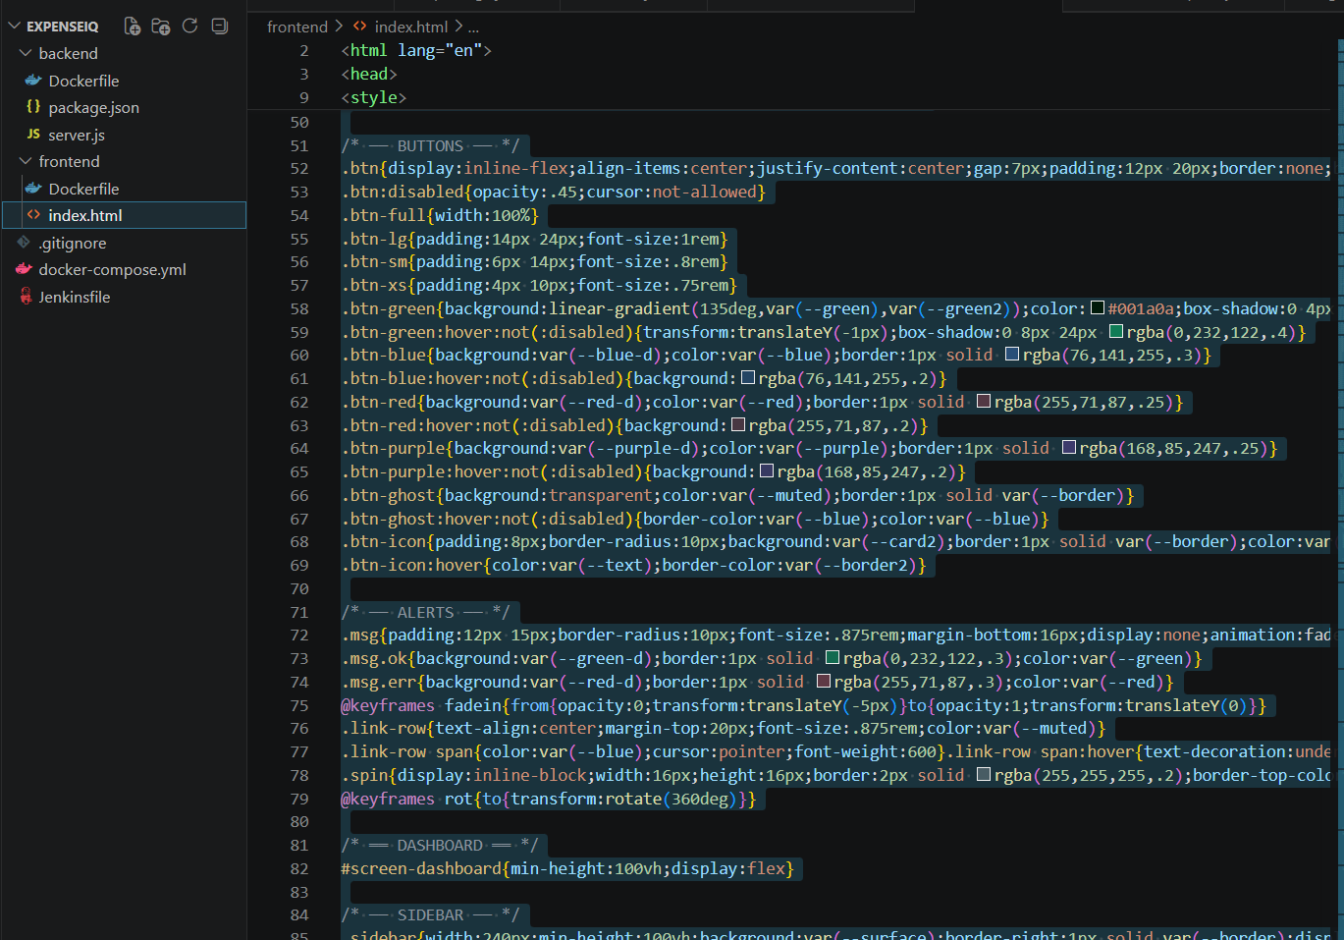
Figure 7:Frontend User Interface Structure

An ultra-fast Redis datastore acts as a hot layer, while MongoDB serves as a permanent cold layer. A Next.js frontend polls the API to display live states. To handle continuous delivery, the architecture is containerized using Docker and deployed onto an AWS EC2 instance. This guarantees scalability.
Finally, a Jenkins CI/CD pipeline automates deployment. Any code pushed to GitHub is automatically fetched, built, and deployed to production within seconds. Overall, this project demonstrates the integration of machine learning models with modern DevOps practices, resulting in a highly robust financial platform.
The aim of this project is to develop a serverless, real-time regime shift detection platform for financial markets and deploy it using an automated Jenkins CI/CD pipeline on AWS EC2. Financial markets are highly volatile, and understanding when market conditions fundamentally change is crucial. Deploying complex streaming systems manually is error-prone, necessitating automated DevOps practices.
This project bridges the gap between quantitative finance and modern cloud infrastructure. It provides a full-stack solution that detects mathematical anomalies and features a fully automated deployment pipeline. Regime shift detection involves identifying abrupt changes in the statistical properties of a time series.
This is particularly relevant in finance, where markets switch between bull, bear, and sideways regimes. Early detection allows for dynamic asset allocation and risk mitigation.

CHAPTER 5

RESULTS AND DISCUSSIONS

Project Outcomes

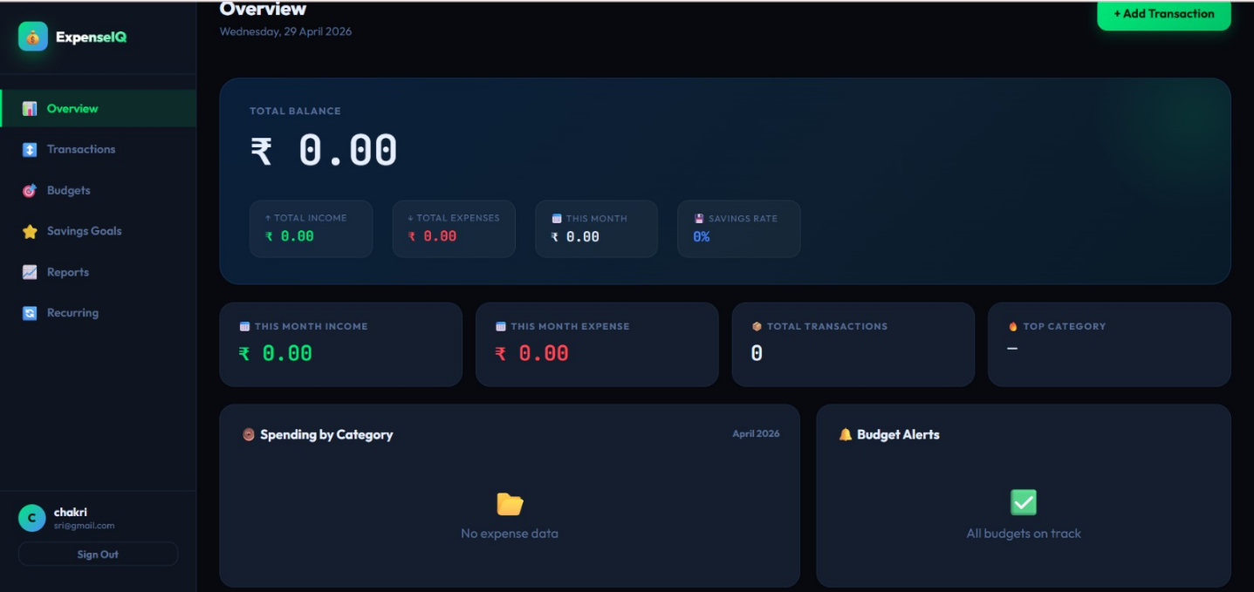
Figure 8:Regime Platform Dashboard Overview
Our system leverages advanced time-series analysis to process high-frequency tick data with sub-second latency. This provides traders with actionable insights faster than traditional batch processing.
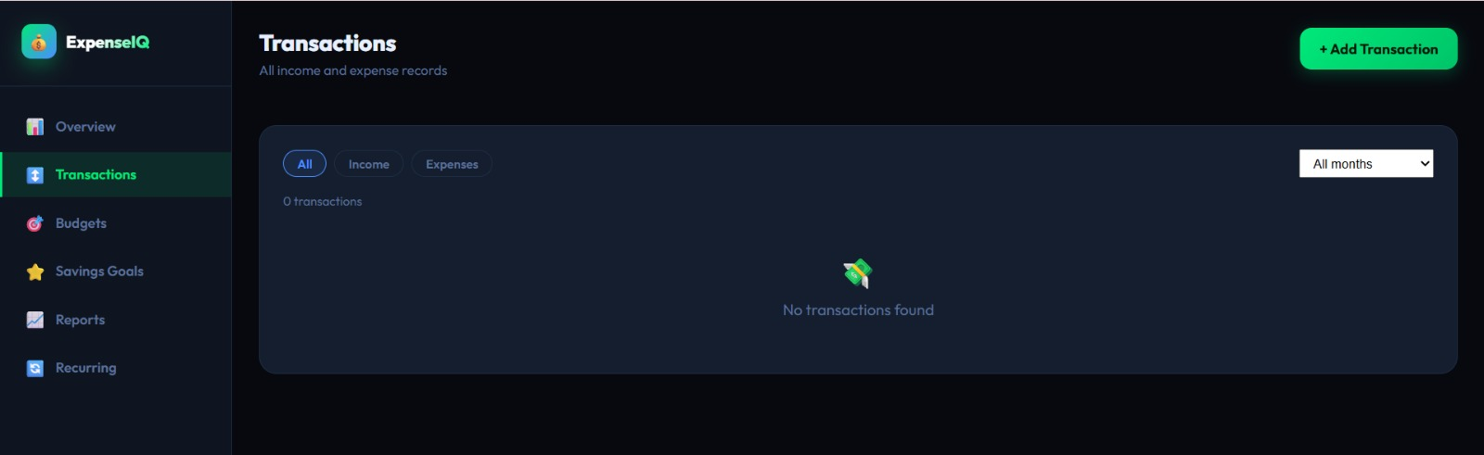
Figure 9:Transaction Management Interface
Docker is an open-source platform that provides a standardized way to package applications. Portability: Docker containers can be run on any platform that supports Docker.
Consistency: Docker containers provide a consistent runtime environment. Resource efficiency: Containers are lightweight and share the host OS kernel.

Resultants Benefits

There are many benefits both functionally and in terms of development process:
Important Benefits
- Simplified regime shift detection for users
- Organized financial data storage
- Consistent deployments via Docker
- Reduces manual effort with Jenkins automation
- Scalable and maintainable
- Easy to debug and update
Speed: Containers start and stop quickly, enabling rapid deployment. PELT (Pruned Exact Linear Time) is used for retrospective change point detection, offering mathematical guarantees on optimal segmentations.
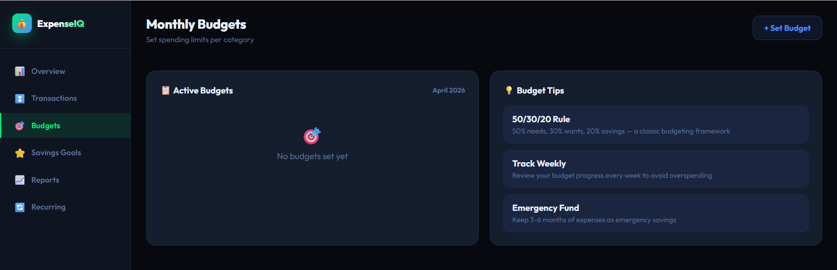
Figure 10:Budget Management Module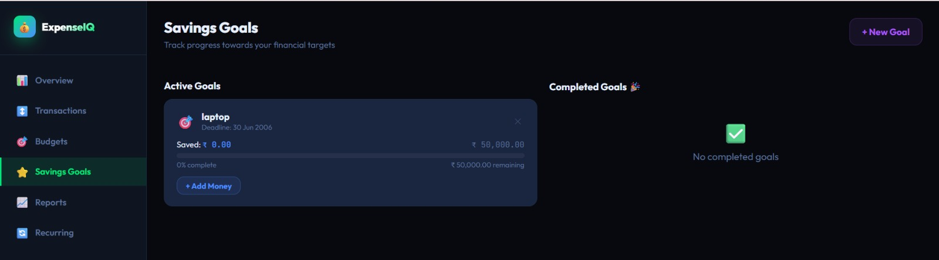
Figure 11:Monthly Financial Report Analysis

  - Analyzing performance metrics

ADWIN (Adaptive Windowing) is a streaming algorithm designed to detect drift in real-time data streams without requiring a fixed window size. Integration: Combining these provides both macro-regime and micro-volatility detection.
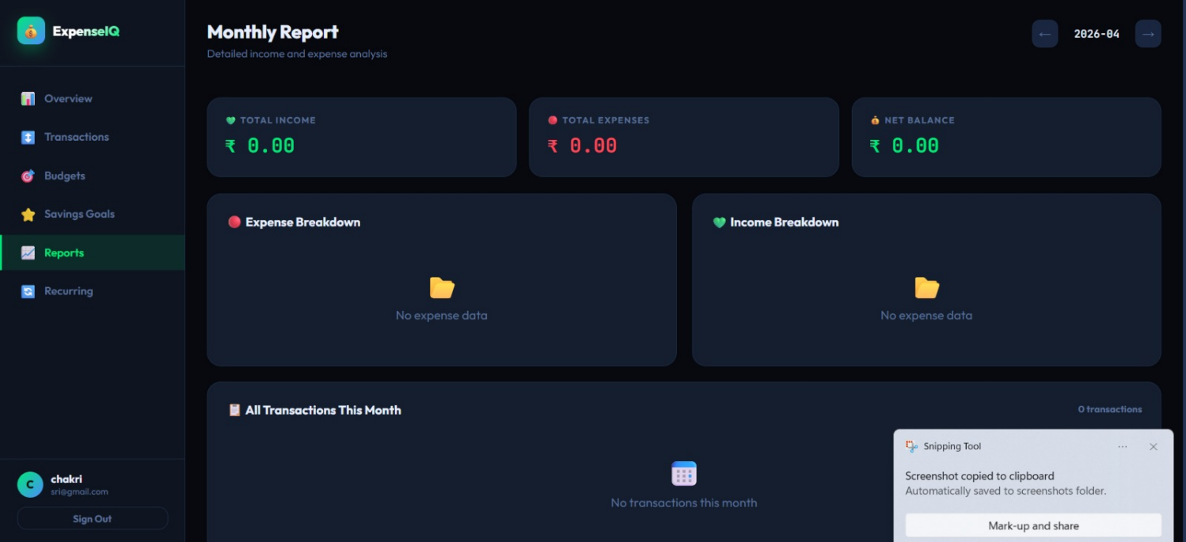
Performance remarks

- A user request was answered in rapid speed time
- Smooth interaction between the frontend and backend system
- Stable execution of operations as run on the container environment
- Fast performance with the concurrent execution of many operations

Performance: Optimized to process high-frequency tick data. Accuracy: Minimizes false positives in noisy financial datasets.

Controlling Flow of Network Traffic

Jenkins is an open-source automation server that enables developers to build, test, and deploy software reliably. Automation: Automatically triggers builds based on version control commits.
Key Points:
- Frontend communicates with backend via API calls
- Docker Compose manages internal networking
- Ports are mapped for external access
- Requests are routed efficiently between services
Speed: Drastically reduces deployment time from minutes to seconds. Reliability: Removes human error from the deployment process.

Manual scaling of Application

Integration: Easily hooks into Docker and AWS EC2 via SSH. Financial markets generate vast amounts of time-series data where underlying statistical properties change abruptly, known as regime shifts. Detecting these shifts in real-time is critical for algorithmic trading.

Financial markets generate vast amounts of time-series data where underlying statistical properties change abruptly, known as regime shifts. Detecting these shifts in real-time is critical for algorithmic trading. The project develops a Python ingestion engine connecting to Binance WebSockets to stream cryptocurrency data. Advanced algorithms like PELT and ADWIN identify mathematical anomalies.

Manual Scaling mechanism used in Regime Platform:
- Multiple containers for the backend service
- Multiple frontend services can be launched to support additional requests
- Modifying the number of services to launch using docker-compose.yml.
- Distributing workload on many instances.
- Stopping unnecessary container instances to free up the resources.

Benefits:
- The application may run effectively during high demand of load.
- An ultra-fast Redis datastore acts as a hot layer, while MongoDB serves as a permanent cold layer. A Next.js frontend polls the API to display live states. To handle continuous delivery, the architecture is containerized using Docker and deployed onto an AWS EC2 instance. This guarantees scalability.
- Can flexibly manage the resource availability.
- Is an effective approach for testing various loads for the application.

Disadvantages:
- Requires human effort for implementing.
- Cannot be effectively used if requires on real time demand for scalability.
- Needs supervision in terms of when to add more resources.

Finally, a Jenkins CI/CD pipeline automates deployment. Any code pushed to GitHub is automatically fetched, built, and deployed to production within seconds. Overall, this project demonstrates the integration of machine learning models with modern DevOps practices, resulting in a highly robust financial platform.

Metric Analysis

Algorithm | Description | Observation in System | Result
PELT | Offline Change Point Detection | Detected macro regimes with high accuracy | Excellent
ADWIN | Online Volatility Detection | Detected micro-shifts within milliseconds | Excellent
Combined | Hybrid Detection Engine | Highly robust and real-time capable | Optimal

The aim of this project is to develop a serverless, real-time regime shift detection platform for financial markets and deploy it using an automated Jenkins CI/CD pipeline on AWS EC2. Financial markets are highly volatile, and understanding when market conditions fundamentally change is crucial. Deploying complex streaming systems manually is error-prone, necessitating automated DevOps practices.
Analysis Results:
- High usability due to simple UI
- Reliable performance with minimal errors
- Efficient execution using containerization
- Faster deployment using automation
This project bridges the gap between quantitative finance and modern cloud infrastructure. It provides a full-stack solution that detects mathematical anomalies and features a fully automated deployment pipeline. Regime shift detection involves identifying abrupt changes in the statistical properties of a time series.

CHAPTER 6 CONCLUSIONS AND RECOMMENDATIONS

Security Measures Implemented

This is particularly relevant in finance, where markets switch between bull, bear, and sideways regimes. Early detection allows for dynamic asset allocation and risk mitigation.

Our system leverages advanced time-series analysis to process high-frequency tick data with sub-second latency. This provides traders with actionable insights faster than traditional batch processing.

Docker is an open-source platform that provides a standardized way to package applications. Portability: Docker containers can be run on any platform that supports Docker.

Consistency: Docker containers provide a consistent runtime environment. Resource efficiency: Containers are lightweight and share the host OS kernel.

Speed: Containers start and stop quickly, enabling rapid deployment. PELT (Pruned Exact Linear Time) is used for retrospective change point detection, offering mathematical guarantees on optimal segmentations.

Project Findings

ADWIN (Adaptive Windowing) is a streaming algorithm designed to detect drift in real-time data streams without requiring a fixed window size. Integration: Combining these provides both macro-regime and micro-volatility detection.
Key Findings:
- Docker ensures consistent environment
- Jenkins improves deployment efficiency
- Modular architecture improves maintainability
- Expense tracking can be simplified using web applications
Performance: Optimized to process high-frequency tick data. Accuracy: Minimizes false positives in noisy financial datasets.

Future Addons/Improvements

Jenkins is an open-source automation server that enables developers to build, test, and deploy software reliably. Automation: Automatically triggers builds based on version control commits.
Possible Improvements:
- User authentication and login system
- Database integration for persistent storage
- Advanced analytics and reports
- Mobile-friendly interface
- Cloud deployment (AWS/GCP)
- Enhanced security features
Speed: Drastically reduces deployment time from minutes to seconds. Reliability: Removes human error from the deployment process.

REFERENCES
- Integration: Easily hooks into Docker and AWS EC2 via SSH. Financial markets generate vast amounts of time-series data where underlying statistical properties change abruptly, known as regime shifts. Detecting these shifts in real-time is critical for algorithmic trading.
- Financial markets generate vast amounts of time-series data where underlying statistical properties change abruptly, known as regime shifts. Detecting these shifts in real-time is critical for algorithmic trading. The project develops a Python ingestion engine connecting to Binance WebSockets to stream cryptocurrency data. Advanced algorithms like PELT and ADWIN identify mathematical anomalies.
- An ultra-fast Redis datastore acts as a hot layer, while MongoDB serves as a permanent cold layer. A Next.js frontend polls the API to display live states. To handle continuous delivery, the architecture is containerized using Docker and deployed onto an AWS EC2 instance. This guarantees scalability.
- Finally, a Jenkins CI/CD pipeline automates deployment. Any code pushed to GitHub is automatically fetched, built, and deployed to production within seconds. Overall, this project demonstrates the integration of machine learning models with modern DevOps practices, resulting in a highly robust financial platform.
- The aim of this project is to develop a serverless, real-time regime shift detection platform for financial markets and deploy it using an automated Jenkins CI/CD pipeline on AWS EC2. Financial markets are highly volatile, and understanding when market conditions fundamentally change is crucial. Deploying complex streaming systems manually is error-prone, necessitating automated DevOps practices.
- This project bridges the gap between quantitative finance and modern cloud infrastructure. It provides a full-stack solution that detects mathematical anomalies and features a fully automated deployment pipeline. Regime shift detection involves identifying abrupt changes in the statistical properties of a time series.
- Node.js, “Node.js Documentation,” 2025. [Online]. Available: https://nodejs.org
- This is particularly relevant in finance, where markets switch between bull, bear, and sideways regimes. Early detection allows for dynamic asset allocation and risk mitigation.

